Samuel Lichtenheld

10/1/2015

Assignment 2

Introduction.

The purpose of this assignment is to get hands on experience with an assembler and disassembler as well as start to make parts of the datapath that will be needed later on.

Setup.

I used C++ for the assembler/diassambler and VHDL and ModelSim for the remainder of the lab.

2.1.1.

|  |  |  |  |  |  |  |
| --- | --- | --- | --- | --- | --- | --- |
|  | Opcode | Rs | Rt | Rd | Shamt | funct |
| OR$4,$5,$2 | 000000 | 00101 | 00010 | 00100 | 00000 | 010101 |
| JR $3 | 00000 | 00011 | 00000 | 00000 | 00000 | 001000 |

|  |  |  |  |  |
| --- | --- | --- | --- | --- |
|  | Opcode | Rs | Rt | Imm |
| BEQ $6, $7, loop | 000100 | 00110 | 00111 | 1111111111111110 |

2.1.2.

0000 0000 0000 00010

Same thing but unsigned

2.1.3.

You can branch 2^18 bytes away, so 2^16 instructions away. This is because there are 16 bits available in the immediate field and this value gets shifted left twice to give a farther range.

You can branch further away with a jump which gives you 25 bits of address space or even further away with jump register, which will jump to the address in a register.

2.2.1

2 separate labels. Thus, 21 instruction + 2 Labels = 23 lines

2.2.2

There are instructions that load only 1 byte, such as load byte. Therefore, it seems to be byte addressable.

|  |  |  |  |  |  |  |  |  |
| --- | --- | --- | --- | --- | --- | --- | --- | --- |
| Name | Mnemonic | Operation | Type | Opcode (hex) | Funct  (hex) | ALU action | ALU function code (bit) | Flags set (**Z**ero, **C**arry (unsigned overflow), **V** (signed overflow), **S**ign(+/-) |
| Add | add | R[rd] = R[rs] + R[rt] | R | 00 | 20 | add | 000 | CZSV |
| add imm. | addi | R[rt] = R[rs] + SignExtImm | I | 08 | - | add | 001 | CZSV |
| add imm. uns. | addiu | R[rt] = R[rs] + ZeroExtImm | I | 09 | - | add | 001 | CZSV |
| add uns. | addu | R[rd] = R[rs] + R[rt] | R | 00 | 21 | add | 000 | CZSV |
| and | and | R[rd] = R[rs] & R[rt] | R | 00 | 24 | and | 000 | SZ |
| and imm. | andi | R[rt] = R[rs] & ZeroExtImm | I | 0C | - | and | 011 | SZ |
| branch eq | beq | if (R[rs]==R[rt])      PC=PC+4+BranchAddr | I | 04 | - | subtract | 010 | CZSV |
| branch not eq | bne | if (R[rs]!=R[rt])      PC=PC+4+BranchAddr | I | 05 | - | subtract | 010 | CZSV |
| jump | j | PC=JumpAddr | J | 02 | - | add | 001 | CZSV |
| jump and link | jal | R[31]=PC+8;PC=JumpAddr | J | 03 | - | add | 001 | CZSV |
| jump reg | jr | PC=R[rs] | R | 00 | 08 | - | 000 |  |
| load byte uns. | lbu | R[rt] = {24’b0,M[R[rs]+SignExtImm](7:0)} | I | 24 | - | add | 001 | CZSV |
| load halfword uns. | lhu | R[rt] = {16’b0,M[R[rs]+SignExtImm](15:0)} | I | 25 | - | add | 001 | CZSV |
| load upper imm. | lui | R[rt] = {imm, 16’b0} | I | 0F | - | - |  |  |
| load word | lw | R[rt] = M[R[rs]+SignExtImm] | I | 23 | - | add | 001 | CZSV |
| Nor | nor | R[rd] = ~(R[rs] | R[rt]) | R | 00 | 27 | NOR | 000 | SZ |
| Or | or | R[rd] = R[rs] | R[rt] | R | 00 | 25 | OR | 000 | SZ |
| Or imm. | ori | R[rt] = R[rs] | ZeroExtImm | I | 0D | - | OR | 100 | SZ |
| set less than | slt | R[rd] = (R[rs]<R[rt]) ? 1:0 | R | 00 | 2A | slt | 000 | SZ |
| set less than imm. | slti | R[rt] = (R[rs]<SignExtImm) ? 1:0 | I | 0A | - | slt | 101 | SZ |
| set less than imm. uns. | sltiu | R[rt] = (R[rs]<SignExtImm) ? 1:0 | I | 0B | - | slt | 101 | SZ |
| set less than uns. | sltu | R[rd] = (R[rs]<R[rt]) ? 1:0 | R | 00 | 2B | slt | 000 | SZ |
| shift left logical | sll | R[rd] = R[rt] << shamt | R | 00 | 00 | sll | 000 | SZ |
| shift right logical | srl | R[rd] = R[rt] >>> shamt | R | 00 | 02 | srl | 000 | SZ |
| store byte | sb | M[R[rs]+SignExtImm}(7:0) = R[rt](7:0) | I | 28 | - | add | 001 |  |
| store halfword | sh | M[R[rs]+SignExtImm}(15:0) = R[rt](15:0) | I | 29 | - | add | 001 |  |
| store word | sw | M[R[rs]+SignExtImm} = R[rt] | I | 2B | -- | add | 001 |  |
| subtract | sub | R[rd] = R[rs] -R[rt] | R | 00 | 22 | subtract | 000 | CZSV |
| subtract uns. | subu | R[rd] = R[rs]= R[rt] | R | 00 | 23 | subtract | 000 | CZSV |



Figure 1: Adder TB

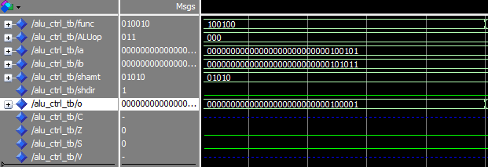

Figure 2: AND ALU + CTRL

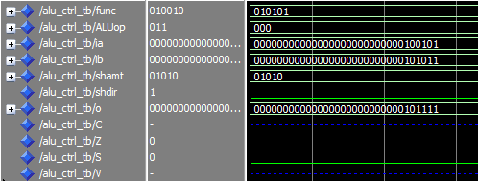

Figure 3: OR ALU + CTRL

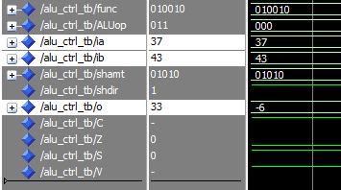

Figure 4: SUB ALU + CTRL

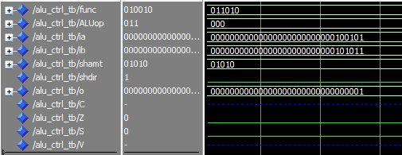

Figure 5: SLT ALU + CTRL

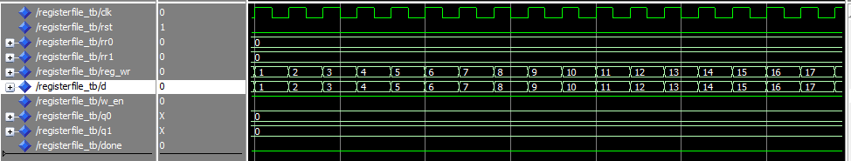

Figure 6: LOAD regfile

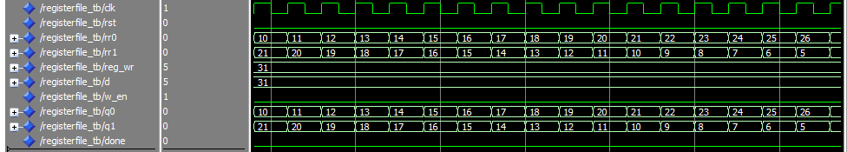

Figure 7: Read from regfile

# ADDER

library ieee;

use ieee.std_logic_1164.all;

use ieee.numeric_std.all;

entity adder_gen is

generic (

width : positive := 32

);

port (

in0 : in std_logic_vector (width-1 downto 0);

in1 : in std_logic_vector (width-1 downto 0);

carry : out std_logic;

sum : out std_logic_vector (width-1 downto 0)

);

end adder_gen;

architecture BHV of adder_gen is

begin

process(in0, in1)

variable temp : unsigned (width downto 0);

begin

temp := unsigned("0"&in0) + unsigned("0"&in1);

sum <= std_logic_vector(temp(width-1 downto 0));

carry <= std_logic(temp(width));

end process;

end BHV;

# ADDER TB

library ieee;

use ieee.std_logic_1164.all;

use ieee.numeric_std.all;

entity adder_gen_tb is

end adder_gen_tb;

architecture TB of adder_gen_tb is

constant width : positive := 32;

signal in0, in1, sum : std_logic_vector(width-1 downto 0);

signal carry: std_logic;

begin

UUT: entity work.adder_gen

generic map (width => width)

port map (

in0 => in0,

in1 => in1,

carry => carry,

sum => sum

);

process

begin

-- test all input combinations

in0 <= std_logic_vector(to_signed(52,width));

in1 <= std_logic_vector(to_signed(106,width));

wait for 10 ns;

in0 <= std_logic_vector(to_signed(5,width));

in1 <= std_logic_vector(to_signed(6,width));

wait for 10 ns;

in0 <= std_logic_vector(to_signed(-5,width));

in1 <= std_logic_vector(to_signed(-6,width));

wait for 10 ns;

in0 <= std_logic_vector(to_signed(-5,width));

in1 <= std_logic_vector(to_signed(6,width));

wait for 10 ns;

in0 <= x"FFFFFFFF";

in1 <= x"FFFFFFFF";

wait for 10 ns;

in0 <= x"00000000";

in1 <= x"00000000";

wait for 10 ns;

in0 <= x"80000000";

in1 <= x"80000000";

wait for 10 ns;

wait;

report "Simulation Finished.";

wait;

end process;

end TB;

# ALU32

library ieee;

use ieee.std_logic_1164.all;

use ieee.numeric_std.all;

entity adder_gen_tb is

end adder_gen_tb;

architecture TB of adder_gen_tb is

constant width : positive := 32;

signal in0, in1, sum : std_logic_vector(width-1 downto 0);

signal carry: std_logic;

begin

UUT: entity work.adder_gen

generic map (width => width)

port map (

in0 => in0,

in1 => in1,

carry => carry,

sum => sum

);

process

begin

-- test all input combinations

in0 <= std_logic_vector(to_signed(52,width));

in1 <= std_logic_vector(to_signed(106,width));

wait for 10 ns;

in0 <= std_logic_vector(to_signed(5,width));

in1 <= std_logic_vector(to_signed(6,width));

wait for 10 ns;

in0 <= std_logic_vector(to_signed(-5,width));

in1 <= std_logic_vector(to_signed(-6,width));

wait for 10 ns;

in0 <= std_logic_vector(to_signed(-5,width));

in1 <= std_logic_vector(to_signed(6,width));

wait for 10 ns;

in0 <= x"FFFFFFFF";

in1 <= x"FFFFFFFF";

wait for 10 ns;

in0 <= x"00000000";

in1 <= x"00000000";

wait for 10 ns;

in0 <= x"80000000";

in1 <= x"80000000";

wait for 10 ns;

wait;

report "Simulation Finished.";

wait;

end process;

end TB;

# ALU32CONTROL

library ieee;

use ieee.std_logic_1164.all;

--ALUop

--R type 000

--add 001

--sub 010

--and 011

--or 100

--slt 101

entity alu32control is

port (

func : in std_logic_vector(5 downto 0);

ALUop : in std_logic_vector(2 downto 0);

control : out std_logic_vector(3 downto 0)

);

end alu32control;

architecture BHV of alu32control is

constant C_ADD : std_logic_vector(3 downto 0) := "0010";

constant C_SUB : std_logic_vector(3 downto 0) := "0110";

constant C_AND : std_logic_vector(3 downto 0) := "0000";

constant C_OR : std_logic_vector(3 downto 0) := "0001";

constant C_NOR : std_logic_vector(3 downto 0) := "1100";

constant C_SLT : std_logic_vector(3 downto 0) := "0111";

constant C_SLTU : std_logic_vector(3 downto 0) := "1111";

constant C_SHL : std_logic_vector(3 downto 0) := "0011";

constant rOp : std_logic_vector(2 downto 0) := "000";

constant addOp : std_logic_vector(2 downto 0) := "001";

constant subOp : std_logic_vector(2 downto 0) := "010";

constant andOp : std_logic_vector(2 downto 0) := "011";

constant orOp : std_logic_vector(2 downto 0) := "100";

constant sltOp : std_logic_vector(2 downto 0) := "101";

constant ADD_F : std_logic_vector(5 downto 0) := "100000";

constant ADDU_F : std_logic_vector(5 downto 0) := "100001";

constant AND_F : std_logic_vector(5 downto 0) := "100100";

constant JR_F : std_logic_vector(5 downto 0) := "001000";

constant NOR_F : std_logic_vector(5 downto 0) := "010111";

constant OR_F : std_logic_vector(5 downto 0) := "010101";

constant SLT_F : std_logic_vector(5 downto 0) := "011010";

constant SLTU_F : std_logic_vector(5 downto 0) := "011011";

constant SLL_F : std_logic_vector(5 downto 0) := "000000";

constant SRL_F : std_logic_vector(5 downto 0) := "000010";

constant SUB_F : std_logic_vector(5 downto 0) := "010010";

constant SUBU_F : std_logic_vector(5 downto 0) := "010011";

begin

process(func, ALUop)

begin

case ALUop is

when rOp =>

case func is

when ADD_F =>

control <= C_ADD;

when ADDU_F =>

control <= C_ADD;

when AND_F =>

control <= C_AND;

when JR_F =>

control <= "----";

when NOR_F =>

control <= C_NOR;

when OR_F =>

control <= C_OR;

when SLT_F =>

control <= C_SLT;

when SLTU_F =>

control <= C_SLTU;

when SLL_F =>

control <= C_SHL;

when SRL_F =>

control <= C_SHL;

when SUB_F =>

control <= C_SUB;

when SUBU_F =>

control <= C_SUB;

when others =>

control <= "----";

end case;

when addOp =>

control <= C_ADD;

when subOp =>

control <= C_SUB;

when andOp =>

control <= C_AND;

when orOp =>

control <= C_OR;

when sltOp =>

control <= C_SLT;

when others =>

control <= "----";

end case;

end process;

end BHV;

## ALU+CTRL

library ieee;

use ieee.std_logic_1164.all;

use ieee.numeric_std.all;

entity alu_ctrl is

port(

func : in std_logic_vector(5 downto 0);

ALUop : in std_logic_vector(2 downto 0);

ia, ib : in std_logic_vector(31 downto 0);

shamt : in std_logic_vector(4 downto 0);

shdir : in std_logic;

o : out std_logic_vector(31 downto 0);

C,Z,S,V : out std_logic

);

end alu_ctrl;

architecture STR of alu_ctrl is

signal ctrlSig : std_logic_vector(3 downto 0);

begin

U_ALU32CONTROL : entity work.alu32control

port map (

func => func,

ALUop => ALUop,

control => ctrlSig

);

U_ALU32: entity work.alu32

port map (

ia => ia,

ib => ib,

ctrl => ctrlSig,

shamt => shamt,

shdir => shdir,

o => o,

C => C,

Z => Z,

S => S,

V => V

);

end STR;

## ALU_CTRL_TB

library ieee;

use ieee.std_logic_1164.all;

use ieee.numeric_std.all;

entity alu_ctrl_tb is

end alu_ctrl_tb;

architecture TB of alu_ctrl_tb is

constant C_ADD : std_logic_vector(3 downto 0) := "0010";

constant C_SUB : std_logic_vector(3 downto 0) := "0110";

constant C_AND : std_logic_vector(3 downto 0) := "0000";

constant C_OR : std_logic_vector(3 downto 0) := "0001";

constant C_NOR : std_logic_vector(3 downto 0) := "1100";

constant C_SLT : std_logic_vector(3 downto 0) := "0111";

constant C_SLTU : std_logic_vector(3 downto 0) := "1111";

constant C_SHL : std_logic_vector(3 downto 0) := "0011";

constant rOp : std_logic_vector(2 downto 0) := "000";

constant addOp : std_logic_vector(2 downto 0) := "001";

constant subOp : std_logic_vector(2 downto 0) := "010";

constant andOp : std_logic_vector(2 downto 0) := "011";

constant orOp : std_logic_vector(2 downto 0) := "100";

constant sltOp : std_logic_vector(2 downto 0) := "101";

constant ADD_F : std_logic_vector(5 downto 0) := "100000";

constant ADDU_F : std_logic_vector(5 downto 0) := "100001";

constant AND_F : std_logic_vector(5 downto 0) := "100100";

constant JR_F : std_logic_vector(5 downto 0) := "001000";

constant NOR_F : std_logic_vector(5 downto 0) := "010111";

constant OR_F : std_logic_vector(5 downto 0) := "010101";

constant SLT_F : std_logic_vector(5 downto 0) := "011010";

constant SLTU_F : std_logic_vector(5 downto 0) := "011011";

constant SLL_F : std_logic_vector(5 downto 0) := "000000";

constant SRL_F : std_logic_vector(5 downto 0) := "000010";

constant SUB_F : std_logic_vector(5 downto 0) := "010010";

constant SUBU_F : std_logic_vector(5 downto 0) := "010011";

signal func : std_logic_vector(5 downto 0);

signal ALUop : std_logic_vector(2 downto 0);

signal ia, ib : std_logic_vector(31 downto 0);

signal shamt : std_logic_vector(4 downto 0);

signal shdir : std_logic;

signal o : std_logic_vector(31 downto 0);

signal C,Z,S,V : std_logic;

begin

UUT: entity work.alu_ctrl

port map(

func => func,

ALUop => ALUop,

ia => ia,

ib => ib,

shamt => shamt,

shdir => shdir,

o => o,

C => C,

Z => Z,

S => S,

V => V

);

process

begin

func <= ADD_F;

ALUop <= rOp;

ia <= std_logic_vector(to_unsigned(37,32));

ib <= std_logic_vector(to_unsigned(43,32));

shamt <= std_logic_vector(to_unsigned(10,5));

shdir <= '0';

wait for 10 ns;

func <= AND_F;

wait for 10 ns;

func <= OR_F;

wait for 10 ns;

func <= SLT_F;

wait for 10 ns;

func <= SLL_F;

wait for 10 ns;

shdir <= '1';

wait for 10 ns;

func <= SUB_F;

wait for 10 ns;

ALUop <= andOp;

wait for 10 ns;

wait;

end process;

end TB;

**REGISTERFILE**

library ieee;

use ieee.std_logic_1164.all;

use ieee.numeric_std.all;

entity registerFile is

port (

clk, rst : in std_logic;

rr0 : in std_logic_vector(4 downto 0); -- register file reads

rr1 : in std_logic_vector(4 downto 0);

reg_wr : in std_logic_vector(4 downto 0); --which reg should be written to on rising edge of clk

d : in std_logic_vector(31 downto 0); -- input word

w_en : in std_logic; -- write register enable

q0, q1 : out std_logic_vector(31 downto 0)

);

end registerFile;

architecture STR of registerFile is

signal ldi : std_logic_vector(31 downto 0);

type rr_array is array(31 downto 0) of std_logic_vector(31 downto 0);

signal q_array: rr_array;

--type registerarray is array(X downto 0) of std_logic_vector(X downto 0);

--signal ra: registerarray;

--The first line defines new a type that is an array of std_logic_vector's; the second line initializes a signal of type “registerarray” with name “ra”. The defined signal can be used in following manner “ra(0) <= 0xDEADBEE7”.

begin

U_REG_ARRAY: for i in 0 to 31 generate

U_REG : entity work.reg_gen

generic map(32)

port map(

clk => clk,

rst => rst,

ld => ldi(i),

d => d,

q => q_array(i)

);

end generate U_REG_ARRAY;

process(clk,rst,rr0,rr1,reg_wr,d,w_en)

variable temp: unsigned (31 downto 0);

begin

q0 <= q_array(to_integer(unsigned(rr0)));

q1 <= q_array(to_integer(unsigned(rr1)));

temp := x"00000000";

if (w_en = '1') then

temp(to_integer(unsigned(reg_wr))) := '1';

end if;

ldi <= std_logic_vector(temp);

end process;

end STR;

**REGISTERFILE TB**

library ieee;

use ieee.std_logic_1164.all;

use ieee.numeric_std.all;

entity registerFile_tb is

end registerFile_tb;

architecture TB of registerFile_tb is

signal clk : std_logic := '0';

signal rst : std_logic;

signal rr0 : std_logic_vector(4 downto 0);

signal rr1 : std_logic_vector(4 downto 0);

signal reg_wr : std_logic_vector(4 downto 0);

signal d : std_logic_vector(31 downto 0);

signal w_en : std_logic;

signal q0 : std_logic_vector(31 downto 0);

signal q1 : std_logic_vector(31 downto 0);

signal done : std_logic := '0';

begin

clk <= not clk and not done after 10 ns;

UUT: entity work.registerFile

port map(

clk => clk,

rst => rst,

rr0 => rr0,

rr1 => rr1,

reg_wr => reg_wr,

d => d,

w_en => w_en,

q0 => q0,

q1 => q1

);

process

begin

rst <= '0';

rr0 <= std_logic_vector(to_unsigned(0,5));

rr1 <= std_logic_vector(to_unsigned(0,5));

reg_wr <= std_logic_vector(to_unsigned(0,5));

d <= std_logic_vector(to_unsigned(0,32));

w_en <= '0';

wait for 1 ns;

rst <= '1';

wait for 19 ns;

rst <= '0';

wait for 10 ns;

for i in 0 to 31 loop

w_en <= '1';

d <= std_logic_vector(to_unsigned(i,32));

reg_wr <= std_logic_vector(to_unsigned(i,5));

wait until rising_edge(clk);

end loop;

w_en <= '0';

wait until rising_edge(clk);

for i in 0 to 31 loop

rr0 <= std_logic_vector(to_unsigned(i,5));

rr1 <= std_logic_vector(to_unsigned(31-i,5));

wait until rising_edge(clk);

end loop;

done <='1';

wait;

end process;

end TB;